Name : Gowtham S
Roll no : 24BAD028
EXPT NO:7 | IMPLEMENT ADVANCED CHART TYPES USING TABLEAU AND  POWER BI
DATE: 14.08.2026

PRE-LAB QUESTIONS

- What is data integration in the context of Business Intelligence (BI)?
Data integration is the process of combining data from different sources into a single, unified dataset. In BI, it helps organizations analyze data together and make better decisions.

- Explain the difference between a join and a data blend in Tableau.
A join combines tables using a common field before analysis and usually requires the data to be in the same data source. A data blend combines data from different data sources during analysis using a common field.

- What are relationships and cardinality (e.g., one-to-many, many-to-many) in Power BI's data model?
A relationship connects two tables using related columns. Cardinality describes how records in one table relate to records in another. Common types are one-to-one (1:1), one-to-many (1:), and many-to-many (:*).

- Why is data quality (e.g., consistent naming conventions, data types) crucial when integrating data from different sources?
Good data quality ensures that data is accurate, consistent, and reliable. Consistent naming conventions and correct data types prevent errors, mismatches, and incorrect analysis.

- Name two common challenges encountered during data integration.
Two common challenges are:
- Inconsistent data formats and naming conventions between sources.
- Missing or duplicate data, which can affect the accuracy of analysis

IN-LAB EXERCISE:
OBJECTIVE:
To connect, combine, and model data from multiple sources in Tableau and Power BI and create a unified, comprehensive dashboard for holistic analysis.

PROCEDURE:
- Data Collection:
  - Import two datasets:
    - Dataset 1: Sales Data (CSV) → Order ID, Order Date, Region, Sales Amount
    - Dataset 2: Regional Sales Targets (Excel) → Region, Sales Target, Target Year
- Data Preparation and Transformation:
  - Clean datasets (e.g., standardize "N. America" → "North America"). • Ensure correct data types (numeric for Sales, date for Order Date).
  - Handle missing values appropriately.
- Data Integration and Modeling:
  - Tableau: Create a join/relationship on the Region field in the Data Source pane.
  - Power BI: Use the Model view to create a relationship on Region; define cardinality (e.g., many-to-one).
- Create Calculated Fields for Comparison:
  - Target Achievement % = (SUM(Sales) / SUM(Sales Target)) * 100
  - Sales vs. Target Variance = SUM(Sales) - SUM(Sales Target)
- Design a Comprehensive Dashboard:
  - Combine visuals from both sources.
  - Add KPI cards: Total Sales, Overall Target Achievement %.
  - Use gauge/bullet charts for region-wise target performance.
  - Combined bar chart: Actual Sales vs. Target by Region.
  - Map visualization: Sales vs. Target Variance by region.
- Validate Data Integrity:
  - Cross-check joined data for accuracy.
  - Ensure dashboard filters correctly update visuals.
- Publishing and Sharing:
  - Tableau: Publish to Tableau Public or Server.
  - Power BI: Publish to Power BI Service and share.

PowerBI Screenshots :
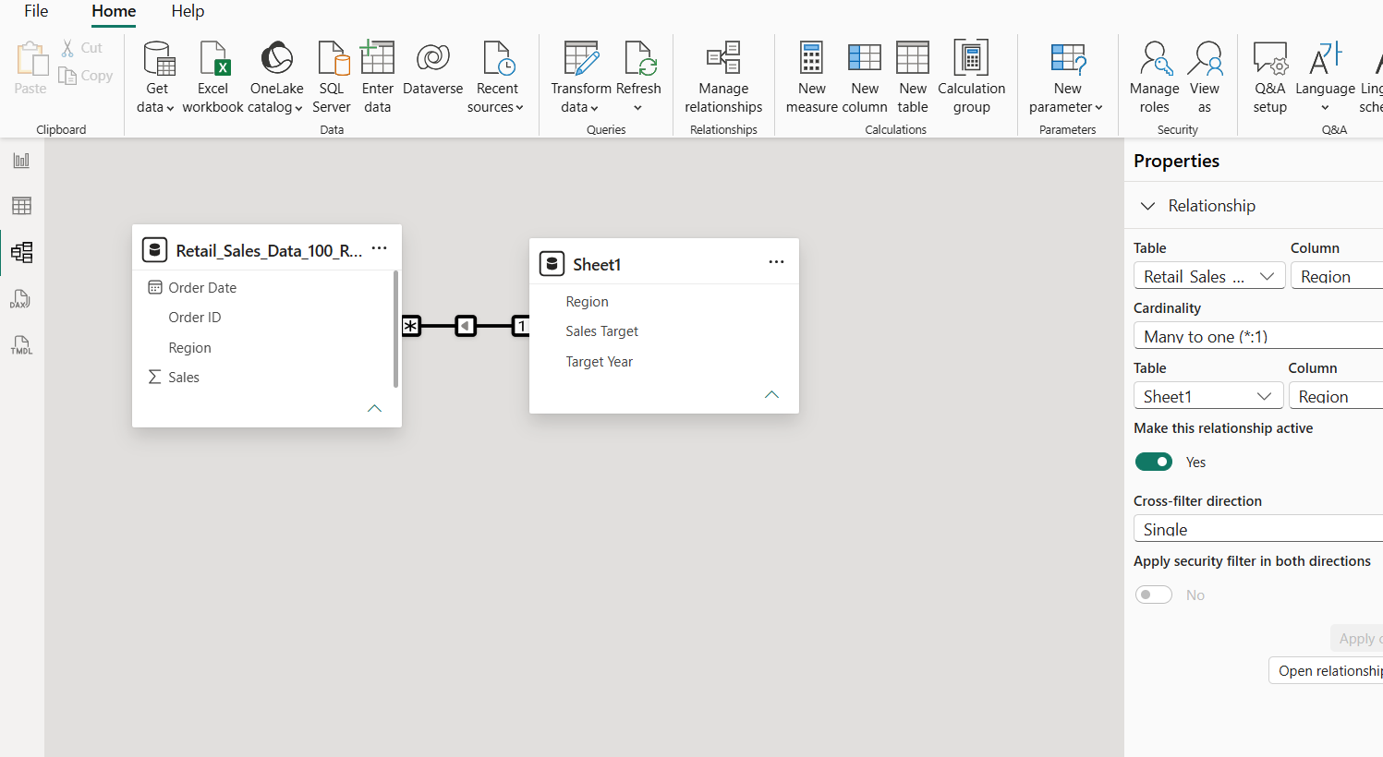
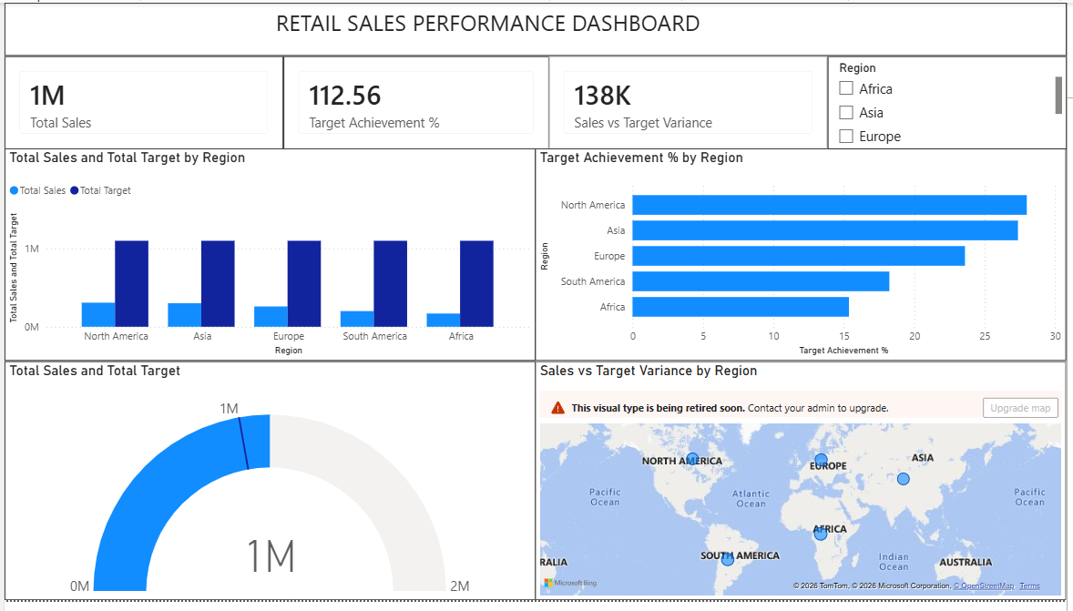

Tableau Screenshots :
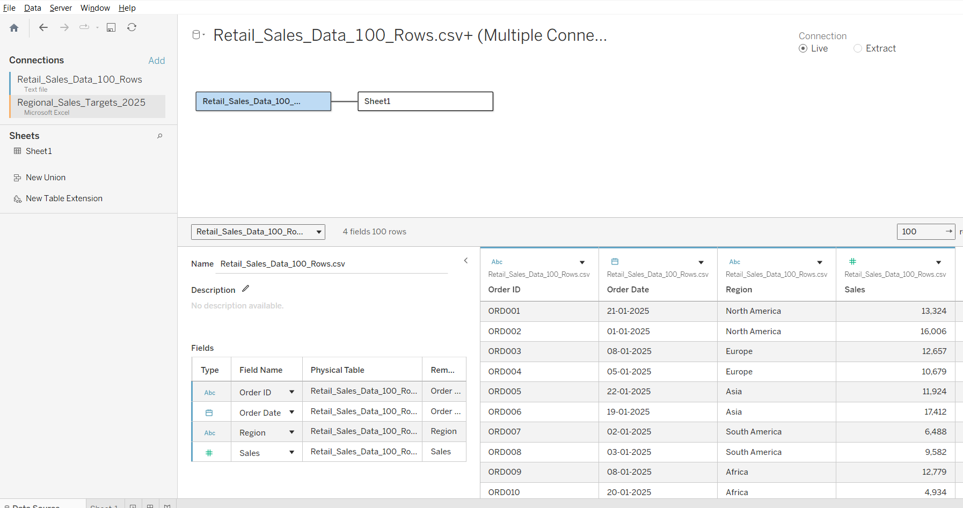
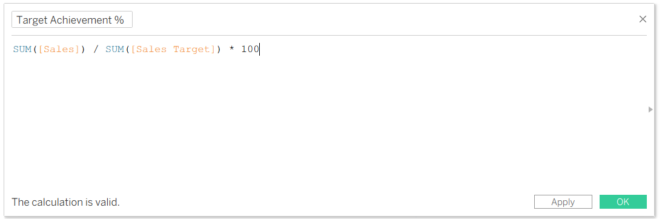
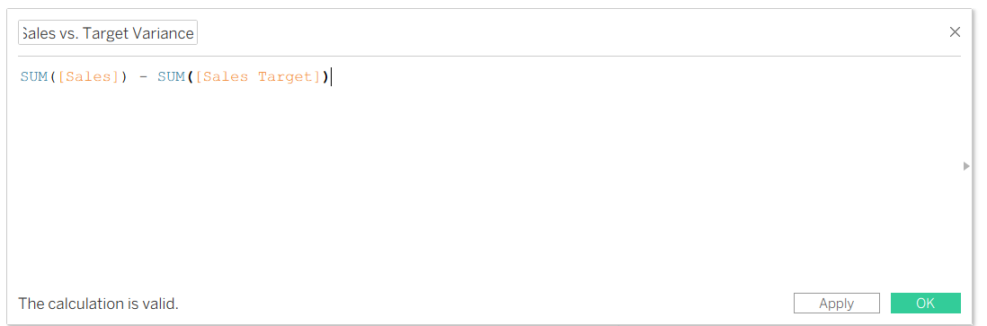
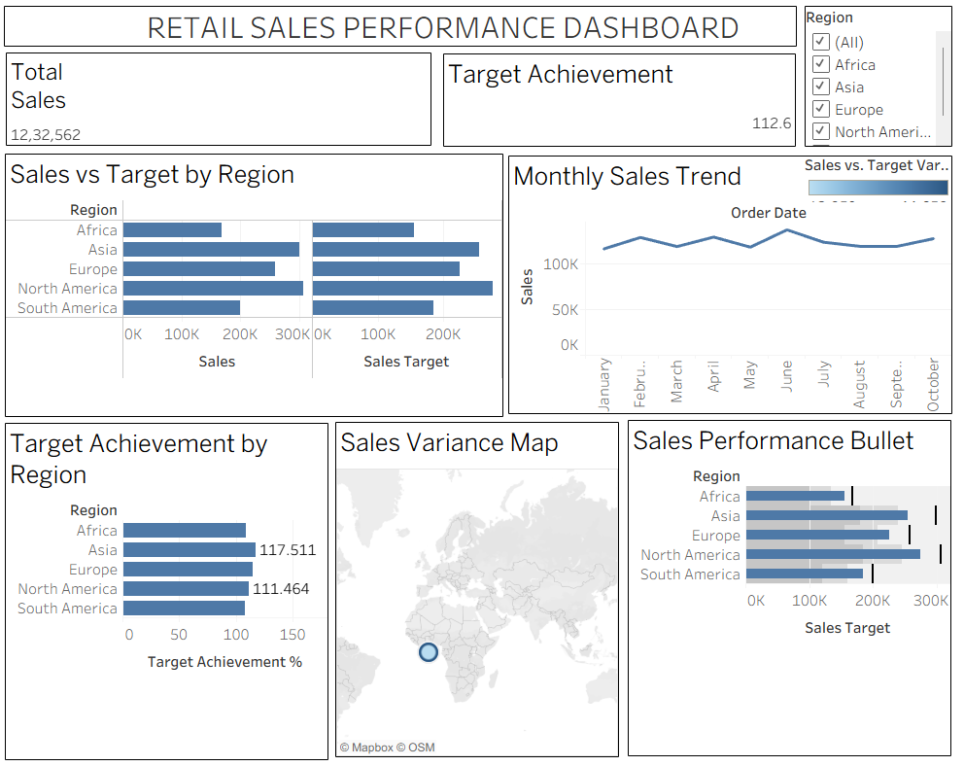

Experiment Datasets:
  - Dataset 1: Retail Sales Data (CSV) → Order ID, Order Date, Region, Sales
  - Dataset 2: Regional Sales Targets (Excel) → Region, Sales Target, Target Year

POST-LAB QUESTIONS

- How did integrating the sales targets data provide a more complete analytical picture than using the sales data alone?
Integrating sales targets allowed us to compare actual sales with planned targets. Sales data alone shows how much was sold, but the target data shows whether the sales performance was successful or below expectations. This helped us calculate Target Achievement % and Sales vs. Target Variance and identify high- and low-performing regions.

- Describe the type of join or relationship you used to combine the two datasets and explain why it was the appropriate choice.
A many-to-one relationship was used based on the Region field. The sales dataset contains many sales records for each region, while the target dataset contains one target value for each region. Therefore, the sales table is the many side and the target table is the one side. This relationship was appropriate because it allows regional sales to be compared correctly with their corresponding targets.

- What challenges, if any, did you face regarding data granularity or mismatched keys (e.g., different region names) between the two sources?
The main challenge was ensuring that the Region names matched exactly in both datasets. For example, differences such as “N. America” and “North America” could prevent correct matching. The datasets also had different levels of granularity: the sales data contained individual orders, while the target data contained regional targets. Standardizing region names and using the appropriate relationship helped resolve these issues.

- How can creating variance calculations (e.g., Sales vs. Target) help a business manager make better decisions?
Variance calculations show the difference between actual sales and the target. A positive variance indicates that a region exceeded its target, while a negative variance indicates underperformance. Managers can use this information to identify weak regions, allocate resources, adjust sales strategies, and set more realistic future targets.

- What other data source (e.g., marketing campaign data, customer demographics) could you integrate to further enrich this analysis, and what new insights might it provide?
Marketing campaign data could be integrated with the sales data. It could include campaign name, advertising cost, campaign dates, and leads generated. This would help determine whether marketing campaigns increased sales and which campaigns provided the best results. It could also help managers understand the relationship between marketing spending and sales performance.

RESULT:

The retail sales and regional targets datasets were successfully connected, cleaned, and integrated in Tableau and Power BI. Relationships between the sources created a unified data model. The dashboard visualized sales performance against targets, enabling variance analysis and providing insights into regional performance not possible with a single data source.

ASSESSMENT

Description |  | Max Marks | Marks Awarded
Pre Lab Exercise |  | 5
In Lab Exercise |  | 10
Post Lab Exercise |  | 5
Viva |  | 10
 | Total | 30
 | Faculty Signature

